Asg7-Subqueries

Paul Polsinelli – 1218203948

IFT 422 – 44909

Prof. Rucker

Jul 4, 2021

Chapter 6

Ex1.

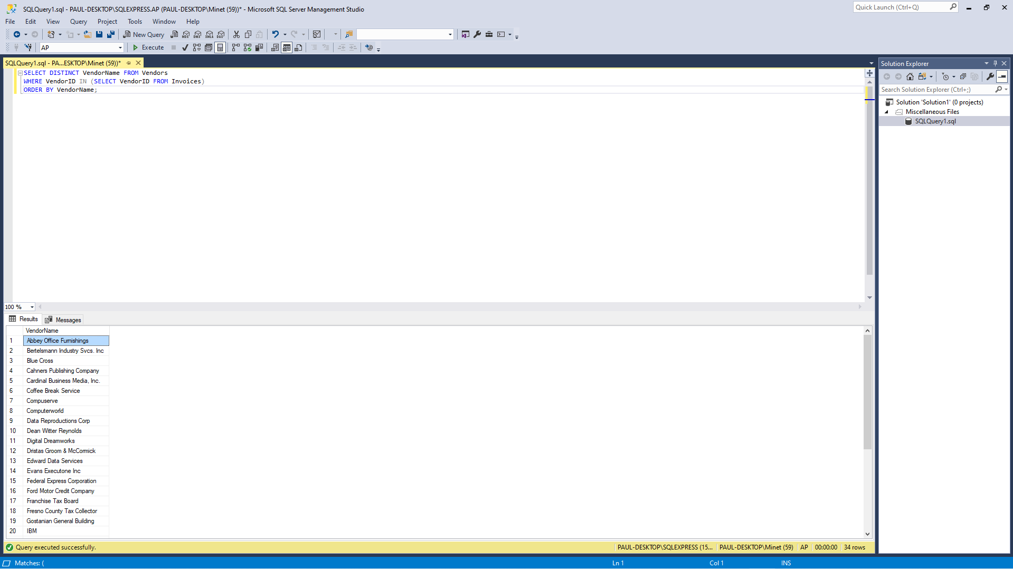

Ex2.

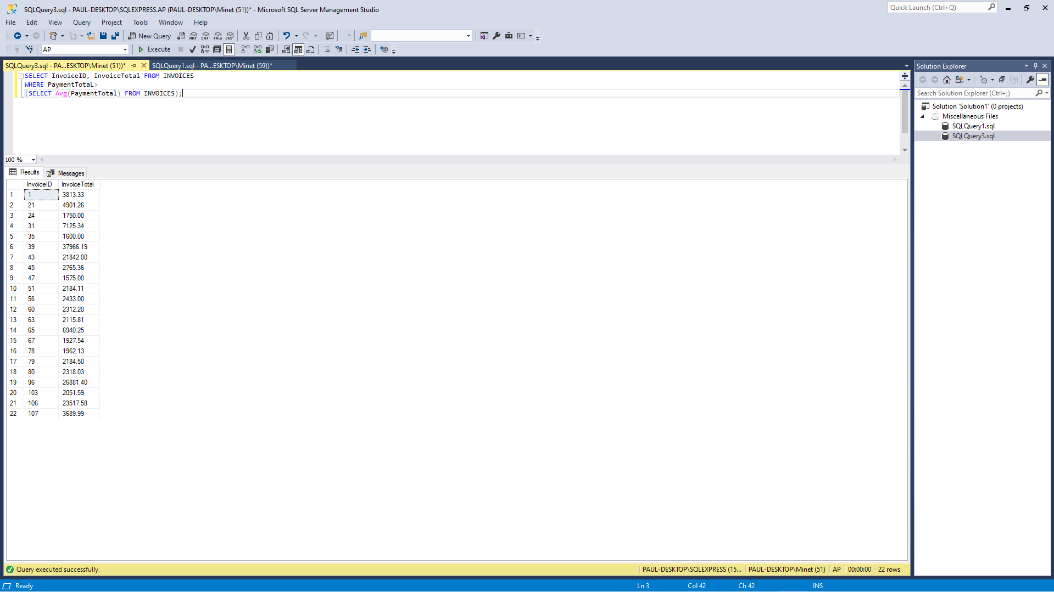

Ex3.

